Week 1 – Simple Commands
Name: Monisha Raghini Chelle
Roll No: 2520030537
Branch: B.Tech CSE
Subject: Linux System Programming
Week: 1

Topic 1: Basic Linux Commands
Sl. No. | Command | Purpose | Example
1 | pwd | Display the current working directory | pwd
2 | clear | Clear the terminal screen | clear
3 | history | Display previously executed commands | history
4 | whoami | Display the current logged-in username | whoami
5 | date | Display the current system date and time | date
6 | cal | Display the calendar | cal
7 | hostname | Display the system hostname | hostname
8 | uname -a | Display operating system information | uname -a
9 | exit | Exit the terminal | exit
Topic 2: Directory Management
10 | ls | List files and directories | ls
11 | ls -l | Display detailed file information | ls -l
12 | ls -a | Display all files including hidden files | ls -a
13 | cd | Change the current directory | cd Documents
14 | cd .. | Move to the parent directory | cd ..
15 | mkdir | Create a new directory | mkdir OSLab
16 | rmdir | Remove an empty directory | rmdir Test
17 | find | Search for files and directories | find . -name "*.c"
18 | locate | Quickly locate files | locate hello.c
Topic 3: File Management
19 | touch | Create a new empty file | touch file1.txt
20 | cat | Display file contents | cat file1.txt
21 | cp | Copy files or directories | cp a.txt b.txt
22 | mv | Move or rename files | mv old.txt new.txt
23 | rm | Delete a file | rm test.txt
24 | head | Display first lines of a file | head hello.c
25 | tail | Display last lines of a file | tail hello.c
26 | more | View a file page by page | more file.txt
27 | less | Scroll through a file | less hello.c
28 | wc | Count lines, words and characters | wc hello.c
29 | diff | Compare two files | diff a.txt b.txt
30 | sort | Sort file contents | sort data.txt
31 | uniq | Remove duplicate lines | uniq data.txt
32 | grep | Search for text inside a file | grep main hello.c
Topic 4: File Editing
33 | nano | Create or edit a file | nano hello.c
34 | vi | Edit a file using Vim editor | vi hello.c
Topic 5: C Program Compilation and Execution
35 | gcc | Compile a C program | gcc hello.c -o hello
36 | ./program | Execute the compiled program | ./hello
37 | which | Locate the executable of a command | which gcc
38 | whereis | Locate binary, source, and manual pages | whereis gcc
39 | man | Display manual pages | man gcc
Topic 6: Process Management
40 | ps | Display running processes | ps
41 | ps -ef | Display all running processes | ps -ef
42 | top | Monitor running processes | top
43 | kill | Terminate a process | kill 1234
44 | kill -9 | Forcefully terminate a process | kill -9 1234
Topic 7: Job Control
45 | jobs | Display background jobs | jobs
46 | bg | Resume a job in the background | bg %1
47 | fg | Bring a job to the foreground | fg %1
48 | & | Run a process in the background | ./hello &
Topic 8: File Permissions and Links
49 | chmod | Change file permissions | chmod +x script.sh
50 | chmod 755 | Set read, write, and execute permissions | chmod 755 script.sh
51 | ln | Create a hard link | ln file1 file2
52 | ln -s | Create a symbolic link | ln -s file1 shortcut
Topic 9: Disk and Memory Information
53 | df -h | Display disk space usage | df -h
54 | du -sh | Display directory size | du -sh .
55 | free -h | Display memory usage (Linux) | free -h
Topic 10: User and Environment Management
56 | id | Display user and group IDs | id
57 | env | Display environment variables | env
58 | export | Set an environment variable | export PATH=$PATH:.
59 | alias | Create a command shortcut | alias ll='ls -l'

Topic 1: Basic Linux Commands
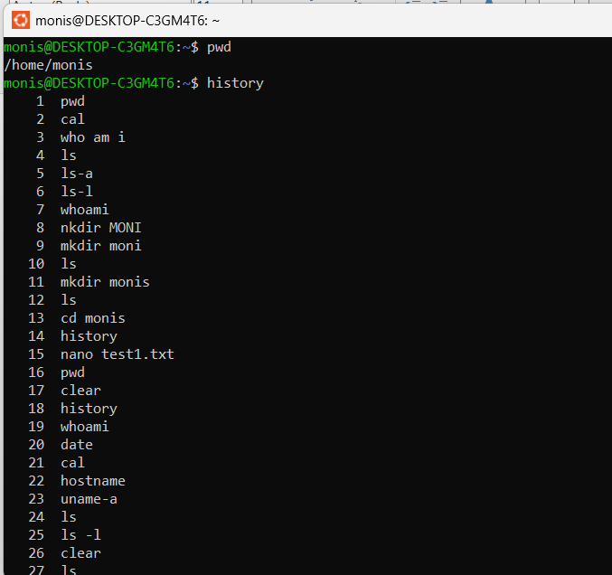

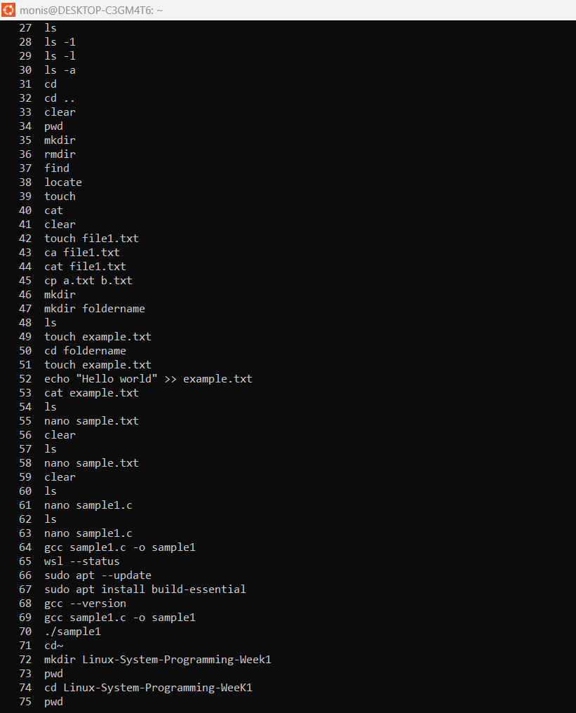

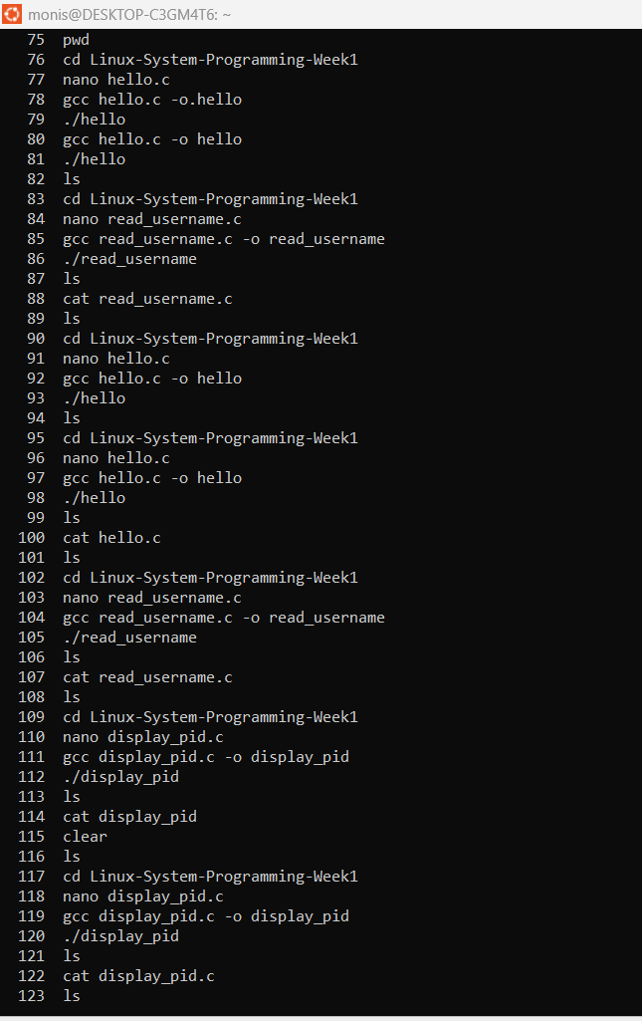

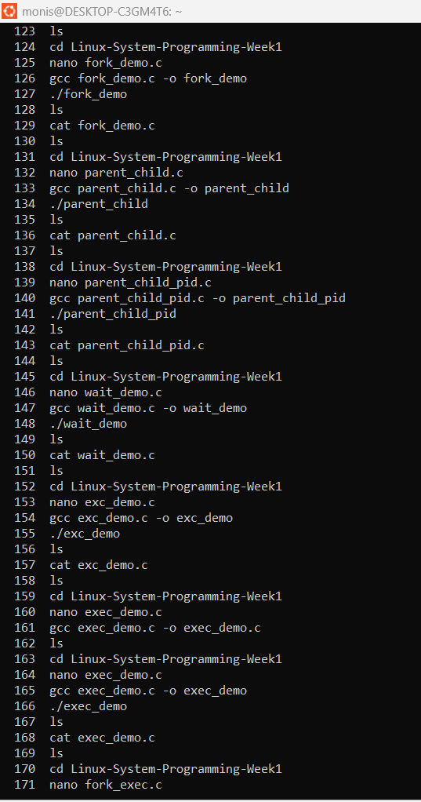

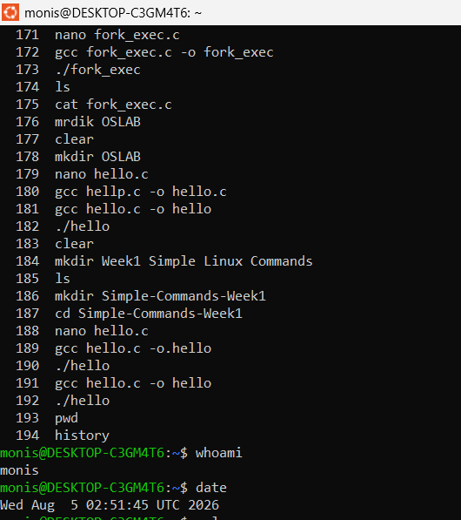
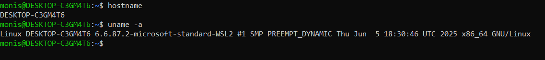

Topic 2: Directory Management

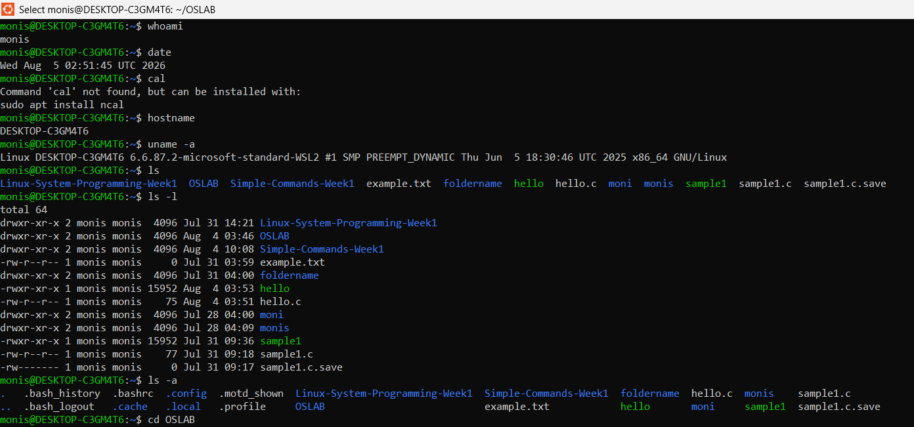

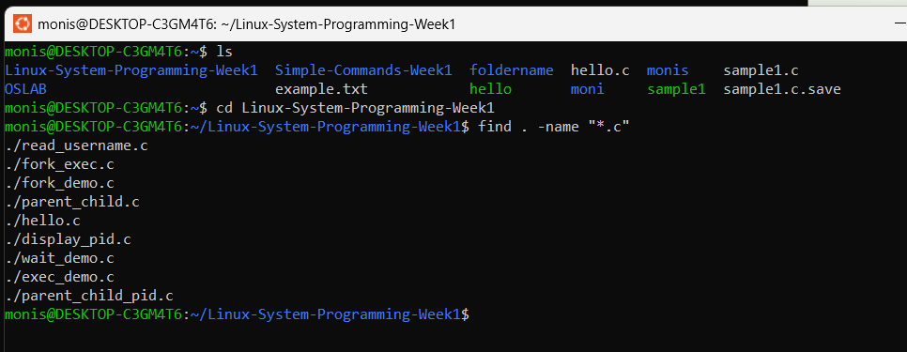

Topic : 3 File Management
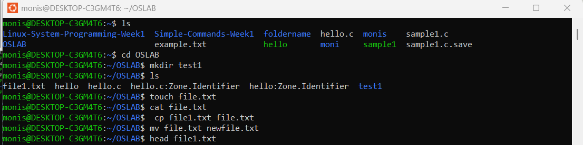

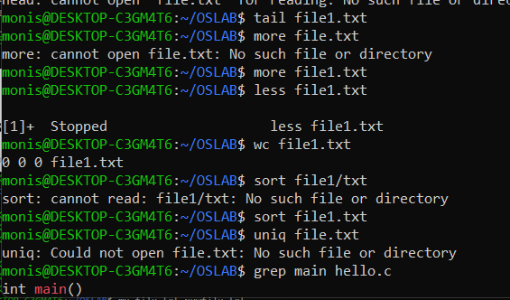

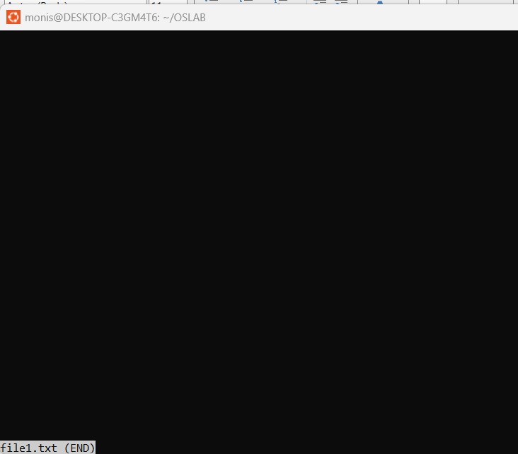

Topic4:File Editing

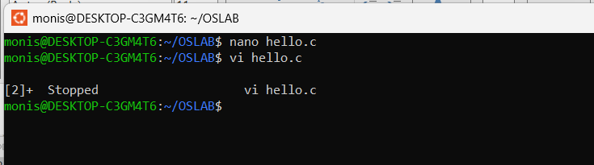

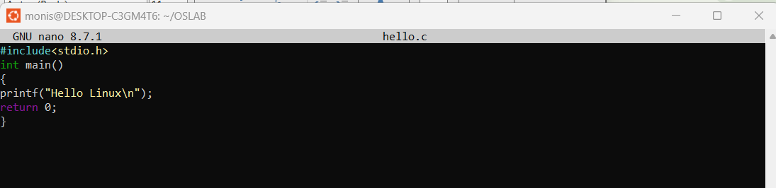

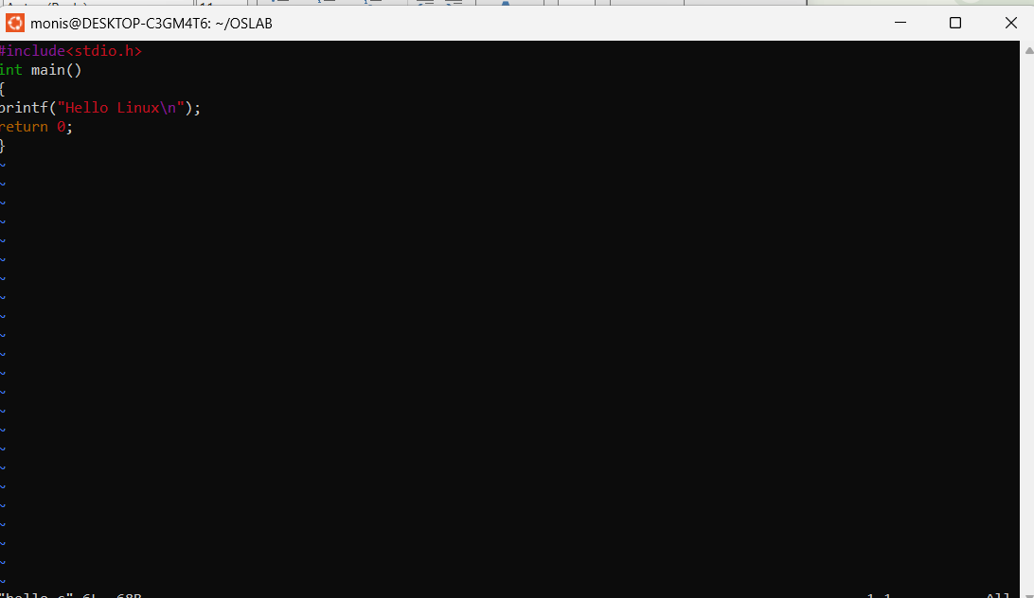

Topic 5: C Program Compilation
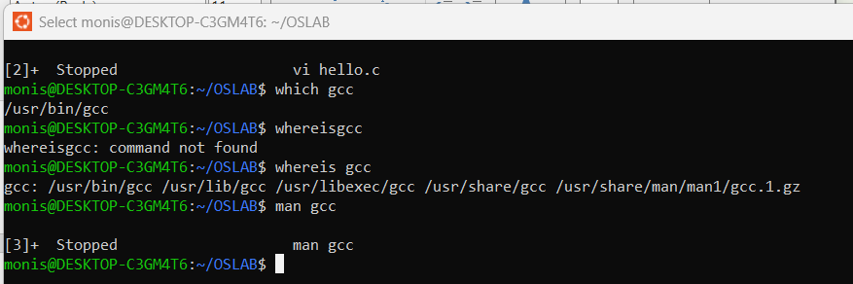
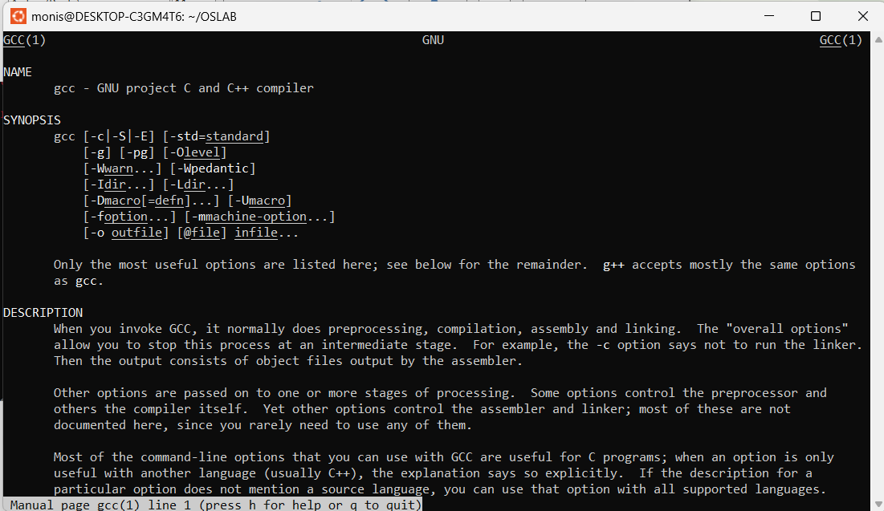

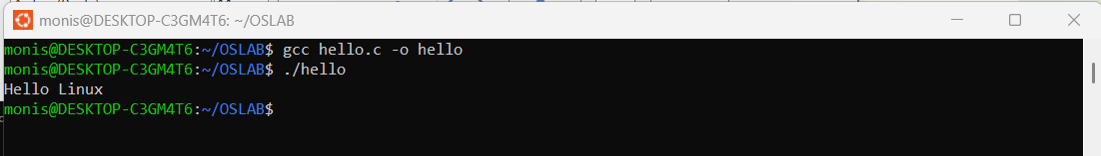

Topic 6: Process Management

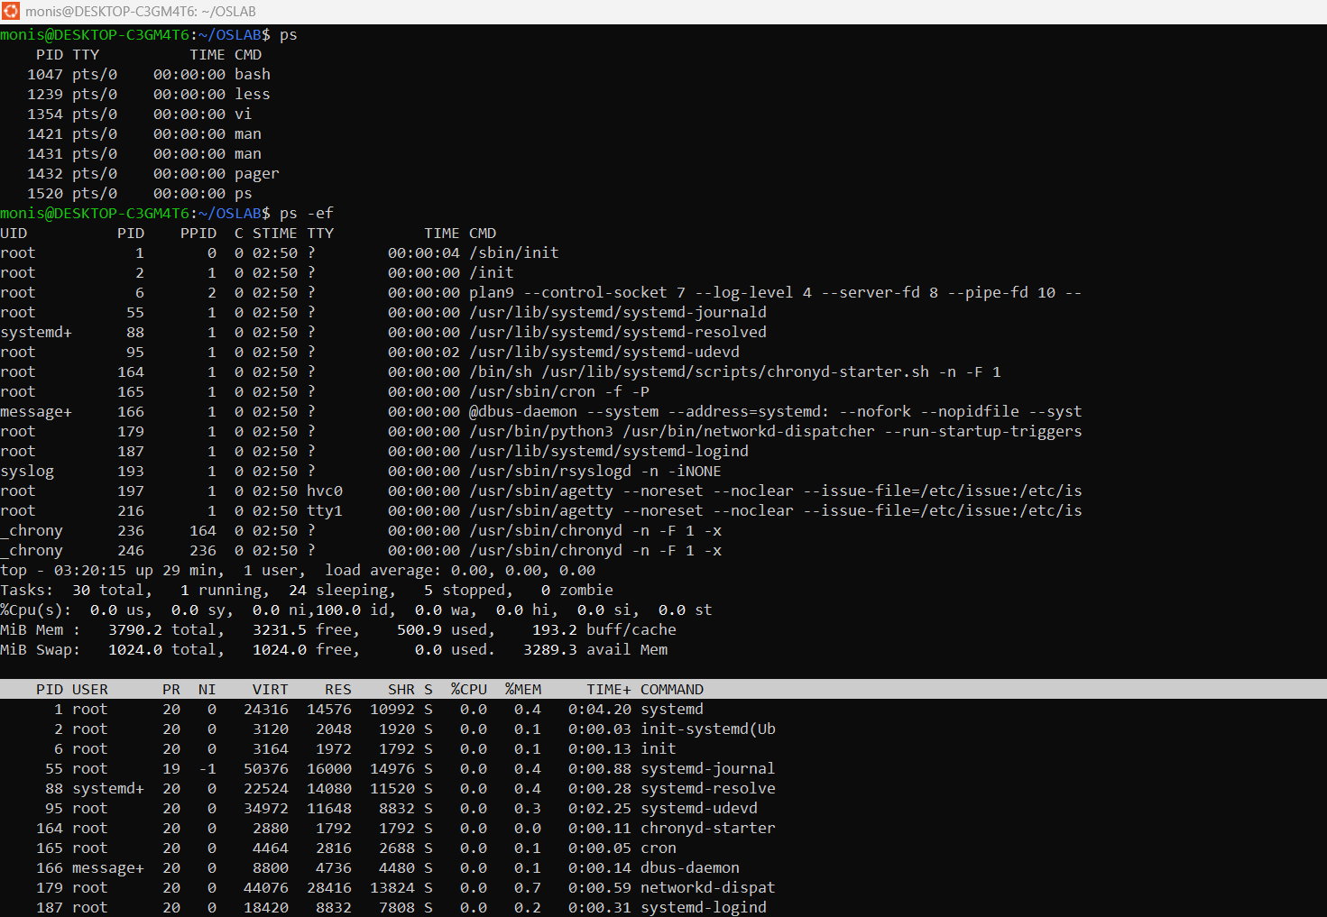

Topic7:Job Control
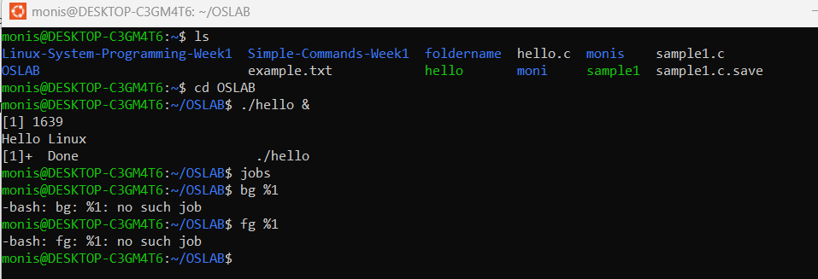

Topic8:File Permissions
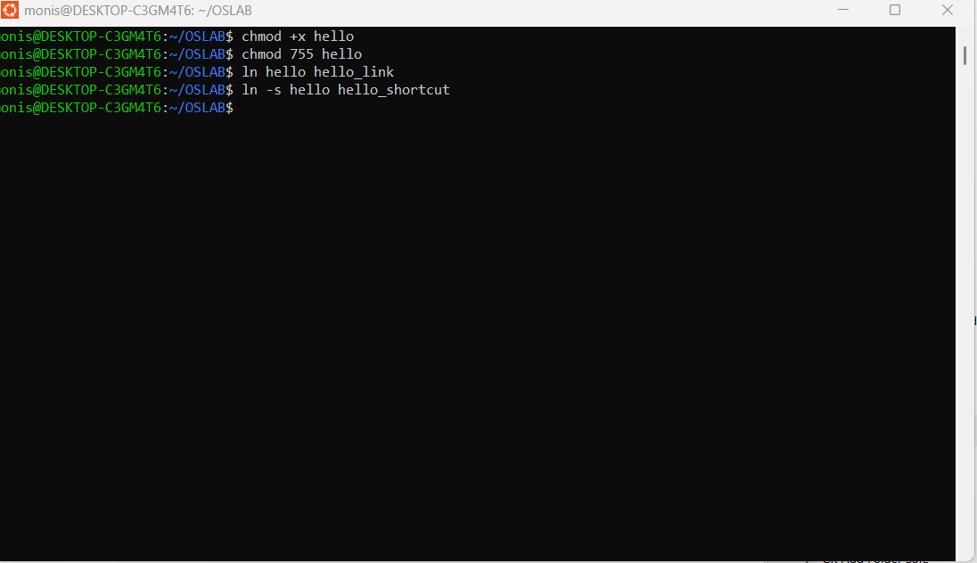

Topic 9:Disk & Memory
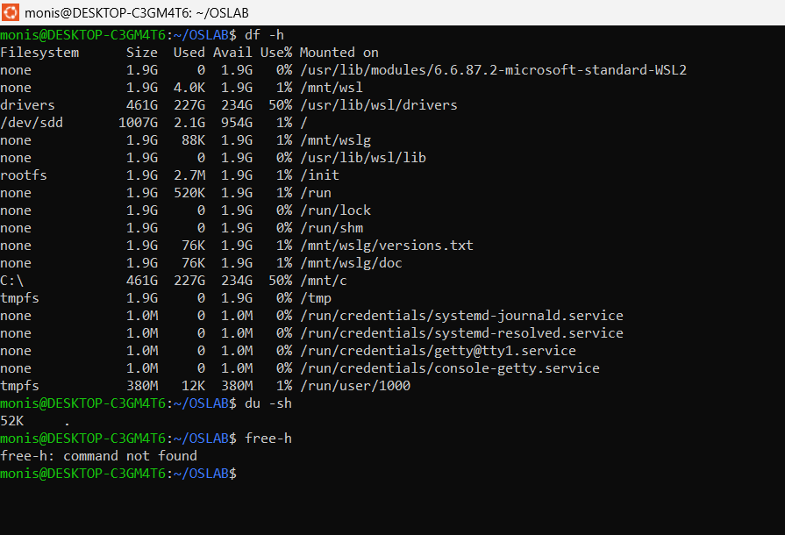

Topic 10: User & Enviroment

